# CS 255 System Design Document

Chironjit Ghosh

Chironjit.ghosh.snhu.edu

## UML Diagrams

### UML Use Case Diagram



### UML Activity Diagrams

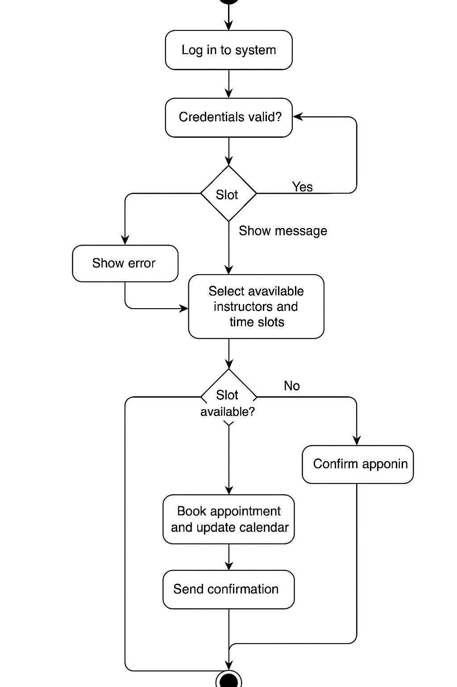

### UML Sequence Diagram

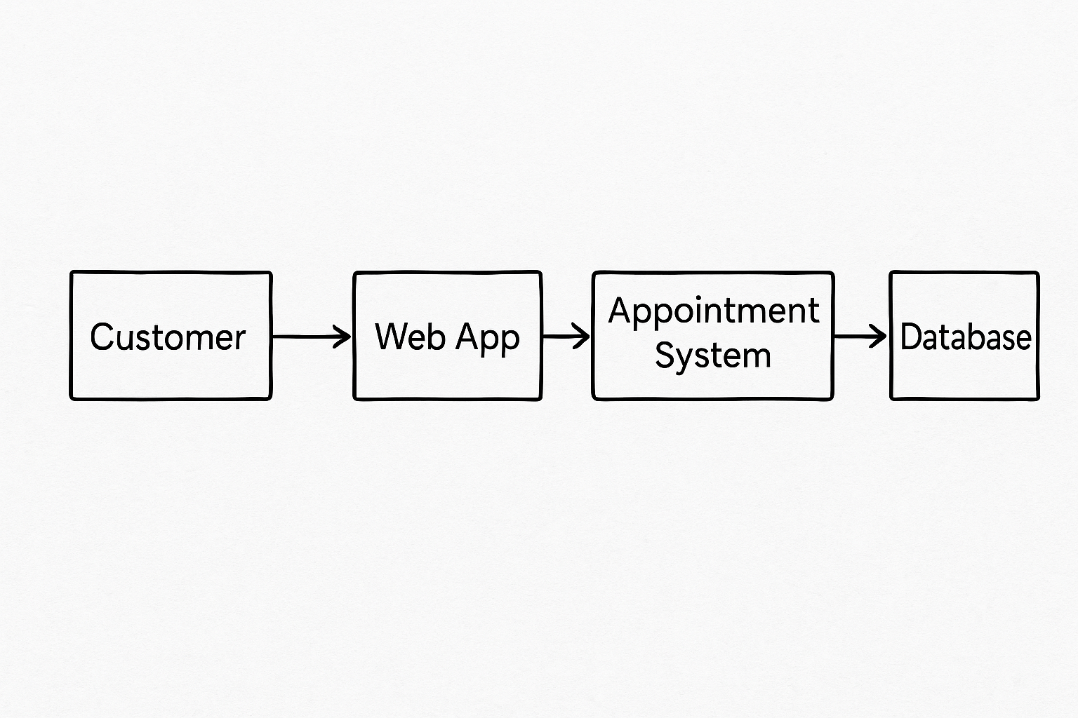

### UML Class Diagram

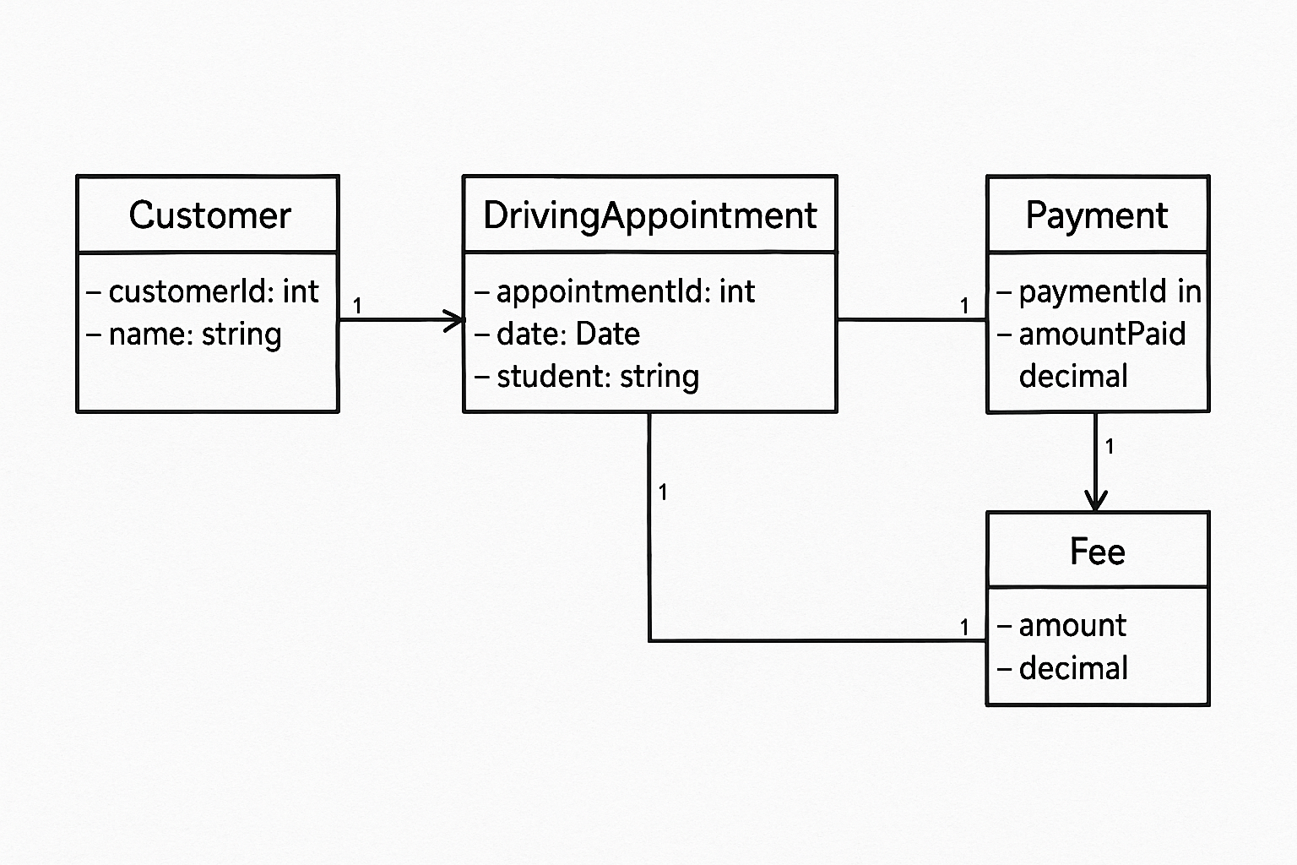

## Technical Requirements

**Hardware Requirements:**

* Cloud-hosted server infrastructure (e.g., AWS, Azure)
* Client devices: Desktop, tablet, and mobile access (modern browsers)

**Software Requirements:**

* Web-based application (HTML5, CSS3, JavaScript frontend)
* Backend using Node.js, Python (Django/Flask), or PHP
* Relational database (MySQL or PostgreSQL)

**Tools & Services:**

* Lucidchart (for diagrams and documentation)
* Version control via GitHub
* Payment processing API (e.g., Stripe)
* Email and SMS notification service (e.g., Twilio)

**Infrastructure:**

* HTTPS for secure communication
* Encrypted database storage for sensitive data
* Role-based access control (Admin, IT, Secretary, Customer)
* Logging system for tracking changes and activity

**Security Considerations:**

* Enforced password complexity and account lockout
* Encrypted user data
* Regular security audits and vulnerability patching